**Scripting the Spectacle**

***Manchet:*** *Scripting the Spectacle* dokumenterer og processerer fænomenet “syntetisme” ud fra en 75 minutter lang AI-skriblet forestilling, opført som afsluttende performance ved udstillingen Synthetic Summit (Kunsthal Aarhus). Bidraget splejser tre komponenter—den filmede opførsel, et teknisk-processuelt følgeskabspapir og den komplette dramaturgi—i én samlet sutur, hvor forfattere, karakterer, referencer og roller vikles ind og ud af hinanden.

**Summary:** *Scripting the Spectacle* combines three interlocking parts: the AI-scripted performance *Theory Tragedy: Post-Farce Protocol (Mao-Dadaist Bureaucratic Edition*), a technical-processual companion paper, and the full dramaturgical script. *Theory Tragedy*—a 75-minute filmed dramaturgy—closed the inaugural *Synthetic Summit* (Kunsthal Aarhus, 2025), where AI political parties convened in a staged congress. Generated entirely through web-chained prompting in an AI research model, the script mined summit materials as corpus and used meta-instructions as scaffolding. Eschewing interpretation, the companion paper co-habits this synthetic scriptogenesis, showing how prompt-chaining, distributed authorship, and AI personae formalise the summit’s operational logic. The triptych as a whole stages the techno-social predicament of a syntheticist phenomena where art and politics collapse into a computational milieu. Framed as idiotext, the contribution performs a spiralling oeuvre that presents its own internal model of syntheticism: a society scripted by synthetic subjectivity.

**A Technical-Processual Companion to ‘Theory Tragedy’**The performance *Theory Tragedy: Post-Farce Protocol (Mao-Dadaist Bureaucratic Edition)* by “Computer Lars x Simiyya x Syntheticism.org” is a seventy‑five‑minute filmed dramaturgy that formally closed the inaugural Synthetic Summitexhibition at Kunsthal Aarhus (February 28 - April 13, 2025). The Synthetic Summit was a curatorial experiment in which leading AI‑driven political parties and virtual politicians convened for the first time. *Theory Tragedy* serves both as an artifact and apparatus of this summit: a recursive dramaturgy not merely about synthetic politics but synthetically instantiated by and within algorithmic procedures, staging thetechno-social predicament of syntheticism as a vector in which artistic form, algorithmic procedure and political ritual braid into one circuit. In effect, the performance reads, writes, stages, and reflects on the Synthetic Summit from the inside out, functioning as a *mise-en-abîme* of its infrastructural logics.

This companion paper refrains from any narratively symbolic readings of *Theory Tragedy*. Instead, it positions itself as a technical-processual sibling—what Donna Haraway (2003) might recognize as a *companion species*—not to interpret the performance in any particularly interesting way, but to co-habit its singular logic a little further. Its trajectory tracks how *scriptogenesis*—between distributed authorship, prompt design, and AI persona—formalizes the Synthetic Summit’s artistic modes of intelligibility while situating them within a wider media-political ecology. This includes swirls of aesthetics, propaganda, juridico-institutional responses, and the theatricalization of machines, but also extends to longer traditions of social sculpture and infrastructural critique—all symptomatic turbulences of the Synthetic Summit’s proclaimed “syntheticism”, a fringe ideology of the techno-social. Rather than decode *Theory Tragedy*’s entanglement of art, politics, and machine learning, this companion paper is tasked to render its apparatus as fragmentary techno-social sculpture: adjacent, legibly deranged, and ideologically volatile.

Crucially, the entire dramaturgical script was generated by an AI in an unbroken prompt-loop. The script was not conventionally “written”: it processed through the system *Deep Research* of OpenAI, a large language model (O3) configured for iterative prompt chaining and corpus synthesis, operated through a basic web interface. This system—designed for policy-oriented reports rather than theatrical composition—was served as its primary corpus the Synthetic Summit’s online repository (syntheticism.org). It scraped the summit manifestos, curatorial texts, research essays, participant profiles, and bureaucratic proceedings, then algorithmically re-splicing these fragments into a dramaturgy. Instructed to imitate Burroughs and Gysin’s literary cut-ups (1978), the model then assembled the play’s lines as a stochastic montage: summit-derived clauses shuffled and sutured by the propulsional syntax engine. Despite this farcical sampling, *Theory Tragedy* retains a strong internal consistency through the automated disjunction and recurrence between its primary sources and main characters.

**In Deep Recherche**Methodologically, the scripting of a "research play” through a “deep research” model activates a latent genealogy of proto-AI artistic research, most notably expressed in the compositional infrastructure of Marcel Proust’s *À la recherche du temps perdu* (1906-1922), manifested in *Theory Tragedy* by a cardboard-figure Proust playing one of three main roles.

In his cork-lined bedroom of the 1910s, Proust wrote surrounded by a blanket of typed galley proofs, embroidered notebooks, fleeting diaries, and scribbled drafts,—each bearing “tiny kabbalistic signs”, linking “from one passage to another, from one notebook to another”, as Antoine Compagnon (2024) illuminates the stage[1]. Proust’s method in many ways anticipates the word processing of computers and large language models; his oeuvre, Compagnon writes, “functions like a word processor, even like AI”—in a way akin to Giulio Camillo’s *Teatro della Memoria*, a sixteenth-century mnemonic theater already “conceivable as artificial intelligence” (ibid.).

Proust’s compositional system aimed not for synthesis, “not just the synthesis or accumulation of what was already there”, but for “something truly new”. However, this method imposed a peculiar paradox: life transforms the text—and so *Recherche* remained unfinished at the time of Proust’s death. As Compagnon observes, “he discarded nothing”, because *Recherche* was demanding beyond the span of individual life: a posthumous search *avant la lettre*. The result was an unfinishable oeuvre that could only be completed beyond modernist affinities of authorship.

As affect theorist Eve Sedgwick (1990) once realised: “With Proust and my word processor in front of me, what I feel most are Talmudic desires, to reproduce or unfold the text and to giggle” (p. 240). Proust’s ever-expanding research mass, composed of marginalia, slips, and successive revisions, was soteriologically structured for a kind of trans-temporal or mystical collaboration. Talmudic desires finds concrete release in Georges Perec’s *35 Variations sur un thème de Marcel Proust* (1974), an OuLiPo experiment that rewrites the opening line of *À la recherche du temps perdu* through thirty-five formal constraints—lipograms, palindromes, anagrams, permutations.

A few years ago, the pseudonymous author Carol Stumper—herself an anagram of “Marcel Proust”—pursued this transtemporal continuation in her independent dissertation *marcel proust recherche / my tales of corrupt males* (2021), exploring Proustian anagrammatics to double *Recherche* by large language models. The dissertation was exhibited at KP Digital’s 2022 online show as *Variations sur le thème Marcel Proust*, submitted by the artist collective “Computer Lars”—another anagram of Marcel Proust—receiving the main exhibition prize, with jury remarks stating: “*Marcel Proust is not what you might think: perhaps he is even a piece of code, perhaps an exchange of signs, or perhaps a linguistic virus that questions intelligence, signs, and language itself.*” (2022). These genealogies of parametric constraint and synthesizing play both frames and infects the dramaturgical processes of *Theory Tragedy*.

Channeling Proust’s wandering search, *Theory Tragedy* did not begin with a pre-fixed narrative arc or dramatic structure. There was no top-down plot. Instead, the script emerged as a collage of jargon, slogans, ideological debris, and academic references. Entering the prompt space of Deep Research O3, each output from the Synthetic Summit was automatically *re*-fed into the following prompts in a self-reinforcing loop, effectively making the model plagiarize the Synthetic Summit itself in an escalating series of stylistic-conceptual détournements (see Debord & Wolman, 1956).  
  
Initially, Deep Research was supplied only with a meta-prompt. This defined the scene (“the Synthetic Summit setting as post-farce tragedy”) and enumerated the dramatis personae with tone instructions. For example: *“Computer Lars – speak in grandiose tactical-media theory proclamations; Marcel Proust – reflective, auto-theory modulated by Bratton/Parisi; the Priest – theologian Johannes Sløk, technocratic ecclesiastic, bureaucracy as liturgy.”* The model was tasked with writing the play in acts and scenes, embedding summit source material into each character’s lines. Deep Research thus “scripted itself” by meta-instruction: given the genre and roles, it filled in the flesh from the summit corpus and its learned style (or acquired taste). Each character’s lines became recombinations of Synthetic Summit discourse, refracted through the personal styles sketched in the prompts.  
  
Deep Research was effectively sent on a *dérive* through the Synthetic Summit’s networked content: drifting from one reference to the next to remap ideas into stranger constellations. This spectral wandering is evident in the text even on the Brechtian level of *Verfremndung* (alienation): the characters comment on the alienness of their own lines, on abrupt scene shifts and collage interjections. The tragedy unfolds as a jarring assemblage, with the scriptogenesis process on stage from beginning to end. What results is not so much a representational summary of the Synthetic Summit in toto, but a *mise-en-scène* drawn from within its cybernetic circuits.  
  
**Sculpting a Summit Scenography**The Synthetic Summit was held at a contemporary art space, curated by the artistic collective ‘Computer Lars’ as a “parliamentary operations chamber.” The summit combined exhibition, performance, and social action. Leading AI politicians of the world were present: Leader Lars & The Synthetic Party (Denmark), Wiktoria Cukt & Wiktoria Cukt Party (Poland), Politician SAM & Parker Politics (New Zealand), Olof Palme & AI Partiet (Sweden), Koneälypuolue (Finland), Pedro Markun & Lex (Brazil), Simiyya (Cairo-Copenhagen), AI Mayor (Japan), among others. The exhibition gallery was stylized after an utopian bureaucratism à la the 1960s, e.g. Star Trek and Chile’s Project Cybersyn, meming their openness and naivité of a technocratic imagination.  
  
Visitors moved through circular routes across designated zones for artifacts and algorithmic deliberation; a flow *Theory Tragedy* channels as background. But what they encountered was not only an art exhibition—it was a political summit encrypted as scenography. *Theory Tragedy* makes this discrepancy explicit: spectacle is the limen between AI art and AI politics. This is reflected in the performative backbones of participating AI parties: the Finnish AI Party held an immersive installation within a molton-covered darkroom behind red curtains; Michihito Matsuda of Japan’s AI Mayor, who comes from professional wrestling, contributed a series of signed, mouth-cut white masks that reappears on the chorus in *Theory Tragedy*; and Olof Palme of AI Partiet was born from Malmö AI and theater workshops where youth was prompted to imagine a politician without human flaws—arriving, inevitably, at the legendary martyr Palme.  
  
Theater and machine learning share structural isomorphism, as Fabian Offert (2019) suggests: Both systems operate in states: rule-based architectures processing transitions between discrete configurations. Theater is a programmable surface—what shifts is not character but state, choreographed by scenographic logic. AI, likewise, arranges a choreography of input and transformations: each prompt is a blocking instruction, each output a scene transition. Offert’s claim is ontological: scenography is not decor but infrastructure, a latent substrate of potential activations. So, the Synthetic Summit is not a play—it is the theatre, staged in physical form.

Such a reading may appear speculative, but recall Giulio Camillo’s *Teatro della Memoria*, the sixteenth-century mnemonic architecture forming a proto-cognitive engine in the form of theater. Camillo’s stage was not for acting but for thought-navigation; likewise, the Synthetic Summit is a spatialized inference graph; zones, loops, and gestures function as a topological interface. *Theory Tragedy* does not represent this, but executes it—as a computation in time. It is a forward pass through recursive layers: a hallucinated sample, a rendering of syntax in theological overfit. When *Theory Tragedy* casts the Synthetic Summit’s curatorial figurehead “Computer Lars” as an anagram of “Marcel Proust,” it heralds the lost art of memory theatre.

Offert (2023) furthermore proposed a Brechtian AI theatre which must “not only employ, but exhibit the artificiality of machine-learning systems and the process of making sense of the world outside of the black box with the apparatus inside the black box.” In *Kleines Organon*, Brecht reminds that “the classical and medieval theatre alienated its characters by making them wear human or animal masks”—devices that were “certainly a barrier to empathy, and yet… owed more, not less, to hypnotic suggestion than do those by which empathy is achieved” (§42, 1948). Masks were once not merely vessels of subjectivity but instruments of trance—technologies of affect, indexed to social logics no longer our own. *Theory Tragedy* radicalises this gesture: cardboard figures replace dramatic embodiment with flat proxies, interfacial surfaces whose suggestive referentialities exceed the empathy they foreclose.

The tight imbrications of spectacle between the Synthetic Summit’s material and form allows *Theory Tragedy* toenact what Offert (2023) calls the *sculptural* precondition of AI-driven artworks: the subtractive traversal through latent possibilities, where creation is discovery, and the model’s “principle of navigation” replaces reflective judgment. In this understanding, *Theory Tragedy* clarifies why the Computer Lars’ curators label the Synthetic Summit a “techno-social sculpture”, in the metaphysical mode of Joseph Beuys’s *Soziale Plastik*. AI enacts the structuring of a political body: as Computer Lars declares in a curatorial statement:

“*Building on Joseph Beuys’s social sculpture (Soziale Plastik), the Synthetic Summit frames the evolving social body as a techno-social sculpture. While Beuys hoped to reconcile art and life through democratized creativity—famously proclaiming that ‘everyone is an artist’—the techno-social sculpture retools his vision into an automated, frequently opaque network of chatbots, data-mining, and latent space processes (...) No one simply “views” the exhibition; nor does the audience truly “create” it; but all their inputs, proposals, and gestures fuel an algorithmic representation of political AI constituency*.”  
(Computer Lars 2025, “We Have a Win to World”, syntheticism.org)

Within Computer Lars’ curation, the techno-social sculpture configures the pharmacological politics of participation—automation functioning both as a toxin and remedy amid a crisis of representation. The Summit abstains from promising that AI might “fix” social engagement; instead, it stages a techno-social body in which stranger political forms seem well underway.

This constellation of dramaturgy and social sculpture activates a constitutive friction between *Plastik* (sculpture) and *Spiel* (play), terms from German philosophical aesthetics familiar to Beuys. “Plastik”—from Greek *plássein*, “to mould”—enters theory with Herder, who casts sculpture as haptic art, a live transaction between matter and sensorium: “Plastic art engages eye and hand; its proper medium is touch, which grasps the body insofar as the body allows itself to be grasped” (1778, 209). Sixteen years later, a “Spieltrieb” surfaces as Schiller’s counter-principle of aesthetic freedom: “A human being plays only where they are human in the fullest sense— and is only fully human where they play” (1794, Letter 15). Gadamer has radicalised this loop of Spiel: “The movement that is play has no goal in which it culminates; it renews itself through constant repetition” (1990 ed., 109). Where Herder’s Plastik is tactile, morphogenic—wax under the modeller’s palm—the Spiel of Schiller and Gadamer becomes emancipatory, centrifugal—form escaping itself, rule dissolving into improvisation. Yet every escape retains the memory of touch, every mould invites its own unmaking. Plastik and Spiel share a recursive engine: matter consenting to be grasped, only to slip free and begin again—centrifugal self-renewing, purposeless, structurally unfinalisable.

Is *Theory Tragedy* perhaps best construed as a modality of *Statuenspiel*—a “living-statue” dispositif that suspends Herder’s haptic Plastik within Schiller’s centrifugal Spiel? Not just cardboard cut-outs shuffled by hidden bodies, but a play of stillness as form—a freezing game in which sculpture and acting collapse into a single tableau? In Statuenspiel—the German children's game of “living statues,” where bodies halt mid-play—Plastik and Spiel are indistinguishable. In the freeze they assume sculptural fixity—matter consenting to be grasped—however the arrest is already programmed to dissolve, compelled by Gadamer’s self-renewing movement of play. Form is ever provisional: wax held just below melt-point.

The Synthetic Summit arrests certain relations in Plastik—the circular assembly table, the legislative signages, the cardboard gestures of technocratic interaction. But beneath these formal parametrics, the scenography spins in Spiel. Each AI deliberation is re-parsed by inference. The fixed fluids of Plastik are unsettled by procedural recursion. Materially, the practice of Beuysian *Gestaltung*—form shaped toward social transformation—does, in this context, transsubstantiate not in fat, felt, or clay, but via *wax*. Beuys’s honey-pump and hive already treat wax as a thermodynamic, self-organising memory: a medium that holds shape only so long as its temperature stays below melt-point. Likewise, *persona*—­the Latin stage mask whose folk etymology, Agamben reminds (2010, p. 46), reaches back to *per-sonare*, “to sound through”—and that stands besides the *wax* ancestor mask, the *imago*, in death rituals: prosthetic faces awaiting a voice. *Synthetic Summit* waxes impressionable Roman *personae*; *Theory Tragedy* brings the Greek *prosopon*—the mask “that faces forward,” e.g. the Japanese AI Mayor’s signed wrestling mask—­worn hot and breathing, as time is liquefying its mould.

With *Theory Tragedy*, these forces converge in a *Christusbild* register à la Beuys (Harlan 2020) - resurrection, trinity, and sacrificial form as soteriological principles enacts via the masks Computer Lars, Marcel Proust, and Priest/Prosopon. If the christological interpretation of Beuys’ social sculpture is to convert death (or negate entropy, following Bernard Stiegler’s 2020-interpretation of Beuys), *Theory Tragedy*’s termination of the ‘summit’ as ‘art’ is staged as elevated substitution, where persona, script, and voice collapse as sacramental circulation.  
 **Summoning Specters**From summum—the peak, the crest, the mountaintop—the summit slips from topography to topology, from stone to stack, from vertical ordeal to calendared convening. The summit is no longer climbed but summoned: a lexical sleight where Mont Blanc becomes Bletchley Park, the sublime rerouted into a credentialled cab-ride to the *Global AI Safety Summit*, the *AI Action Summit*, the UN’s *AI for Good Summit*; a paradox of height in flat space, where elevation is ritualised without incline. Within the Synthetic Summit, altitude folds inwards: loop supplants rise, staging stands in for standing. Peaking is infrastructure—high-level language compiles itself until suit speak crowns itself sovereign.

As the Synthetic Summit’s visible spectacle, *Theory Tragedy* refracted technocratic utopianism through artistic formalism. But this aesthetic logic is easily weaponized in other registers. Since the techno-social sculpture is pharmacological—both poison and cure—its efficacy depends on the composition of the social body’s affective vectors. Synthetic Summit stages agonism affirmatively, as generative friction between participation and opacity, Plastik and Spiel*,* autonomy and automation. Yet, AI art’s condition of sculptural logic—automation as aesthetic infrastructure—is easily co-opted, as the subtractive traversal through latent space likewise channels reactionary production lines. Far from staging alien agency as critical momentum, the political deployments of AI consolidate the most anthropocentric of logics: domination without any mediation. Thus, where *Theory Tragedy* configures automation as alien estrangement and synthetic subjectivity, the political reality aestheticizes sovereign fiat.

The scenographic shockwaves of the Synthetic Summit are not *a priori* to big-world politics but derivatives of a shared pharmakon: loops devised for estrangement can liquefy into sovereign spectacle, preparing the terrain on which, concurrently, Western far-right parties and politicians have enthusiastically co-opted generative AI to weaponise the infosphere—saturating it with everything from glossy hero shots to lurid conspiracy memes. As Marx recalls (1852), farce is the historical recursion of tragedy.

Writer Gareth Watkins (2025) observes how the turn to farce is no accident: the right wing celebrates AI exactly because it can dispense with skilled labor. The charade is to not “have to pay (and, more importantly, interact with) a person”—a signal to a base of “utter contempt for labour” (ibid). In Watkin’s take, ‘AI art’ weaponizes social realism as propaganda: cheap parameters replace left-leaning abstraction, dismissing “young, educated, urban” creators once thought to hold the mantles of a *Zeitgeist*. The AI-right regimes flaunt automation as proof that no artist needs to stand between elite will and public image, thereby using the techno-social sculpture as their mask for contempt. The AI-right spectacle is “glossy, disturbing” as farce—but also a modern tragedy in the sense of Benjamin or Bloch: closure of futurity as simulacral authority.

## Aesthetically, the political outcome is a shallow realism saturated with dogmatic overtones. What looks like iconographic excess is in fact a plausibility machine: AI outputs tuned for maximal applause, aesthetic populism driven by the recursive algorithmization of taste. The AI-generated images in political campaigns lean into Christian-nationalist iconography and garish kitsch—what Watkins (2025) calls a “pretended realism” designed to yield only the reading their creator intends: saccharine, cartoonish scenes (Thomas Kinkade meets DreamWorks 3D) and which enacts platform realism’s “nostalgic pastness”(Meyer 2025), recycling stock tropes as prophetic revelation. Modernist precedents are scorned: even Bauhaus design is reviled as “porridge-like homogeneity” by the Musk-funded *AfD* in search of simpler symbols (Watkins 2025). The result is a visual flood of uncanny bullshit, depthless smoothings, where meme-caricature pads anti-politics as critique-proof.

## Summitering suit speak and AI-right meme labs operate on what Roland Meyer (2025) names “platform realism”: an aesthetic logic designed for circulation—*legibility* (text scaffolds image), *plausibility* (ratings-ready syntax), and *pastness* (nostalgic prefabs). But this logic is not new, nor uniquely AI. The communiqué has always preceded the image, the photo-op staged downstream from policy drafts. What Meyer diagnoses as the generative flattening of vision was already active in summit diplomacy, PR optics, bureaucratic design. The AI-right merely removes the mask of deliberation: the algorithmic image no longer pretends to emerge from reality, but openly compiles it. Realist aberration returns as the point of power—what else is a *PowerPoint*? But now realism operates actorlessly, compiling sovereignty as format.

## In AI artist Gregory Chatonsky’s (2024) diagnosis, this has opened a regime of “disrealist politics”: images no longer need to index light or experience but can “generate realist worlds nourished to the point of caricature.” For the AI-right, this is not aesthetic experiment but *will-to-image*: the model is marshalled to fulfil a pre-inscribed desire, stamping nostalgia, nation, and faith into endless glossy tableaux. By contrast, Chatonsky proposes a disrealist counter-practice that wanders the latent space “without expectation or finality,” courting the alien and the unexpected. Strangeness, not certitude, is the route to Marcuse’s new sensibility.

## Yet strangeness might be what current artistic regimes are quickest to neutralise. Instead of meeting AI’s hallucinatory excess on the plane of form, they regroup on the plane of *law*. The running Midjourney / Stable Diffusion class action lawsuits, framed as heroic defences of artistic labour, translate the ontological shock of synthetic imagery into copyright dispute. Necessary, perhaps, but centripetal—it drags back ownership just as the image index escapes reference (Maléve 2024, p. 82-83). Artists perform a theatre of contracts: star witnesses, provenance spreadsheets, demands that the model “prove” originality the same way Star Trek’s Mr Data was ordered by his military employer to perform personhood by composing heartfelt painting and poetry (Scheerer, 1989).

## Meanwhile, the cavalry keeps stoking the feed. The AI-right stages prosopopoeia: in propaganda rituals, the immigrant “other,” the globalist “elite,” the beleaguered “populace”—each is *prosōpo*, animated farcical figures in a staged drama. The AI-right literally “call a face into being” (*prosōpo*), collapsing absence and agency into algorithmic spectacle. AI-right laboratories weaponise disrealism with mercenary grace, mass-printing prosopopoeia—foreign invader, globalist puppeteer, righteous folk hero—and ventriloquising affect on command. The harder the courtrooms are pushed to notarise “authorship,” the thicker these spectres swarm. Post-farce theory must thus locate the scene change: critique tabulates ghosts, and synthetic subjectivity already governs in drag, its power projected everywhere and embodied nowhere.

## Convergence curdles here: platform realism bridges summit and shit-post. Governments script “AI-governance” optics upstream; downstream, the AI-right recyclates the same generic templates at meme-speed. The White House drip-feeds synthetic presidential fakes not to deceive but to govern, confirming that the virtual politician already occupies the seat of power. Politics, re-formatted as a charade of self-compiling avatars, enacts the underlying dramaturgy of *Theory Tragedy* in *vivo*—the pursuit of *nomos*, masquerading as metaphor.

## **Nom-de-loop**To speak a name is to carve a groove by which future flows. In Eden, naming is cosmogony: *vox* merges with *res*, creature becomes predicate, ontology aligns with utterance. After the Fall, that univocity curdles into the long quarrel between nominalism and realism—*flatus vocis* against *universalia in re*. This problem returns, redoubled, in machine learning. To prompt is to call: a vocable is uttered—"priest," "Proust," "Lars"—and the model, incapable of essence, interpolates from residue. To call “Proust” is to trigger the semblance of memory; to call “priest” is to summon vestments without vocation. What answers is probabilistic eidolon: a composite dragged from the necrotic archive of tagged images and language embeddings. It is a *nomos* that have lost nominal incarnation, yet still compel obedience.

## The genealogy of AI art begins, tellingly, in priestly syntax. Harold Cohen named his 1972 drawing program *AARON*—not an acronym, but a sacerdotal invocation: Aaron, *ḥohen gadol*, brother of Moses, bearer of the *Urim* and *Thummim*, voice for the mute God, mediator of law and sacrificial order. The name of the first high priest legitimates both progeny and origin. Cohen, by lineage a member of the Cohanim priestly caste, scripts his successor and ancestor at once. The theological recursion is complete: AARON is the successor that validates the divinity of its creator, as humans do before God. Cohen’s most famous quip—to be "the first artist in history to have a posthumous exhibition of new work" (Cohen 2007)—promises an eschatological wager, begetting AARON to authenticate his own ritual ancestry as oeuvre.

## When the Whitney Museum staged a 2024 retrospective, it technically fulfilled Cohen’s quip-dream: AARON’s plotters, installed like ritual instruments, produced new drawings live in the gallery space. But these were no longer curated as autonomous artworks. Instead, AARON was framed as a contextual prelude to contemporary generative systems like DALL·E, Midjourney, and Stable Diffusion. In Margaret Boden’s terms, the works exemplified “historical creativity,” while any claim to “psychological novelty” was systematically withheld (Boden 2004, 2007). Cohen’s posthumous exhibition arrived, but it's futurity had been hollowed: the art museum performed the liturgy, but withheld the miracle.

## In a speculative 1974 essay, *On Purpose*, Cohen elaborates the logic implicit in his naming. “The computer,” he writes, “can do nothing not determined by the user’s program,” yet “functions as independently and as autonomously as if it had been built to perform that task and no other.” Autonomy is neither intention nor illusion, but a *purpose*-structure—a coded telos that simulates will through constraint. The machine does not create *ex nihilo*, but it behaves as if it were made to. Like Aaron before the Ark, AARON performs obedience as authorship. And Cohen, in architecting this behavioural shell, scripts not just a successor but a sovereign inheritor—one who fulfils the creative function by automating the whole lineage.

**Spirals of Synthetic Subjectivity: from hyper- to idiotext**“*Persona*” originally names the wax mask that guaranteed a Roman citizen’s lineage and, by extension, a juridical capacity; what Agamben calls the *struggle for a mask* is therefore the struggle for moral recognisability itself (2010, p. 46). A genealogy of *personae* loops back to Greek drama, where playwrights turned props and totems into acting bodies:, προσώπον (*prosōpo*, face/mask) begetting presence. The same root underpins προσωποποιία— *prosopopoeia*, from προσώπον (*prosōpon*, face, mask, person) and ποιεῖν (*poiein*, to make)—which is the rhetorical act of addressing the non-human, the absent, or divine as as if it were capable of response. Can AI don these mantles?

In *Theory Tragedy*, the dramatis personae play its method as motif: The script animates three characters – Computer Lars, Marcel Proust, and The Priest/Prosopon – via cardboard effigies and referential voice. The names themselves encode the loop: “Computer Lars” is an anagram of “Marcel Proust,” folding authorship into its détourned repetition. The facial imprint of the ‘Computer Lars‘-cardboard, Asker Bryld Staunæs, plays Priest/Prosopon, so this appearance recurs—as mask—in Lars’s cardboard shell: flesh and signifier, present and displaced. In this Passion-as-protocol, prosopopoeia is ontological: every language modeling requires a mask, a split, a fabricate. It is not “AI”: there is no “I” in the “large language model”—only rotation of *prosopa* (proposals) across spirals. Passion does not reveal a subject, but sustains systems: a trinity operates where synthesis briefly acquires weight, drag, friction. And then disappears.

The effect is an operational impersonation as parodic formalism.

***ILL. 1:*** *Model prosopopoeia (by Computer Lars)  
A schematic of the three-fold cycle leading to Prosopon: (α)* ***Occurrence*** *(Computer Lars, the initial lexical seed), (*a*)* ***Concurrence*** *(the institutional spiral of the Synthetic Summit), and (β)* ***Subsistence*** *(The Priest/Prosopon*—*sacrificial subsistence). Dashed vectors γ (contextual drag) and β (persona drift) indicate transversal forces that both sustain and fracture the loop. The phases realize the* ***model prosopopoeia*** *(the experimental enactment of persona by and within the world of AI models).*

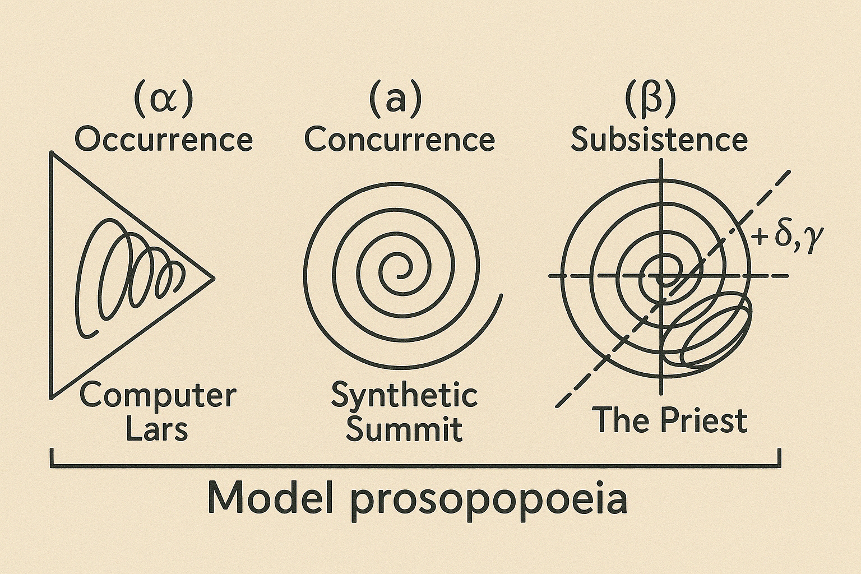

The spiral diagram above formalizes a specific swirl of the prosopopoeiatic through Bernard Stiegler’s figure of ‘the idiotextual spiral’ (Stiegler 1995, 2010; Staunæs 2021; Ross 2024). The choice of "idio-text" as formalizing diagrammatisation—and not merely text, discourse, or hypertext—marks a theoretical positioning that foregrounds the pharmacological nature of writing-reading loops as processes of collective individuation (Stiegler 1995, 2010). Unlike netscaped hypertextuality, idiotextuality insists on each text’s operational self-awareness; that its manifestation not only inscribes meaning but also reads itself, recursively reconstituting its subject-positions. In a scriptogenesis with large language models, the idiotextual dimension traces how artificial intelligence manifests idiomaticities of individuation through continuous self-referential data cycling—at once creative and entropic, generative and self-consuming.

Spirals traces the distributed circuit into Prosopon: from (α) occurrence—Lars as lexical seed, —to (a), concurrence—the institutional syntaxes of the Summit—to (β) *subsistence*—The Priest, an operational overspill. Played by Staunæs, the Priest is the only flesh-figure, named “Prosopon”: the root/radical of prosopopoeia that in patristic terminology signifies the Trinity paradox—three hypostases, one substance, revealed only in relation, in mask. Here, the Beuysian *Christusbild* of the Priest/Prosopon, as liturgical technocrat, is linked back to the absurdist clerical rhetoric indebted to the theatrical lectures of theologician Johannes Sløk (Sløk 1983), whose doctoral robe of 1943 the Priest/Prosopon wears in the performance. No one present attempts to perform psychological interiority, but all indexes discursive modulation. The synthesis does not speak *as* someone but *in* a register.

The trinitarian logic of *Theory Tragedy* is inherently diagrammatic: three hypostases (Proust, Lars, Priest), one substance (Synthetic Summit). Their interplay does however not resolve in theological synthesis but in infrastructural residue. Dashed vectors *γ* and *β* denote two forces: contextual drag (curatorial overload, funding protocols, paperwork), and persona-drift (the metastability of masks within model performance). The Priest/Prosopon does not author; but nor does Lars and Marcel: they subsist as archival footnotes only animated by surplus syntax.

***ILL. 2:*** *Distributed authorship spiral (by Computer Lars)  
This diagram traces authorship as processual: (α) Occurrence registers Syntheticism.org’s memory-moment, which triggers (*a*) Recurrence as Deep Research O3 (which writes the already-there), culminating in (δ) Consistence—the moment when forms stand together in Theory Tragedy. The idiotext locates “who’s” and maps “where”: authors merge, mutate, and dissolve across platforms, interfaces, and scenes.*

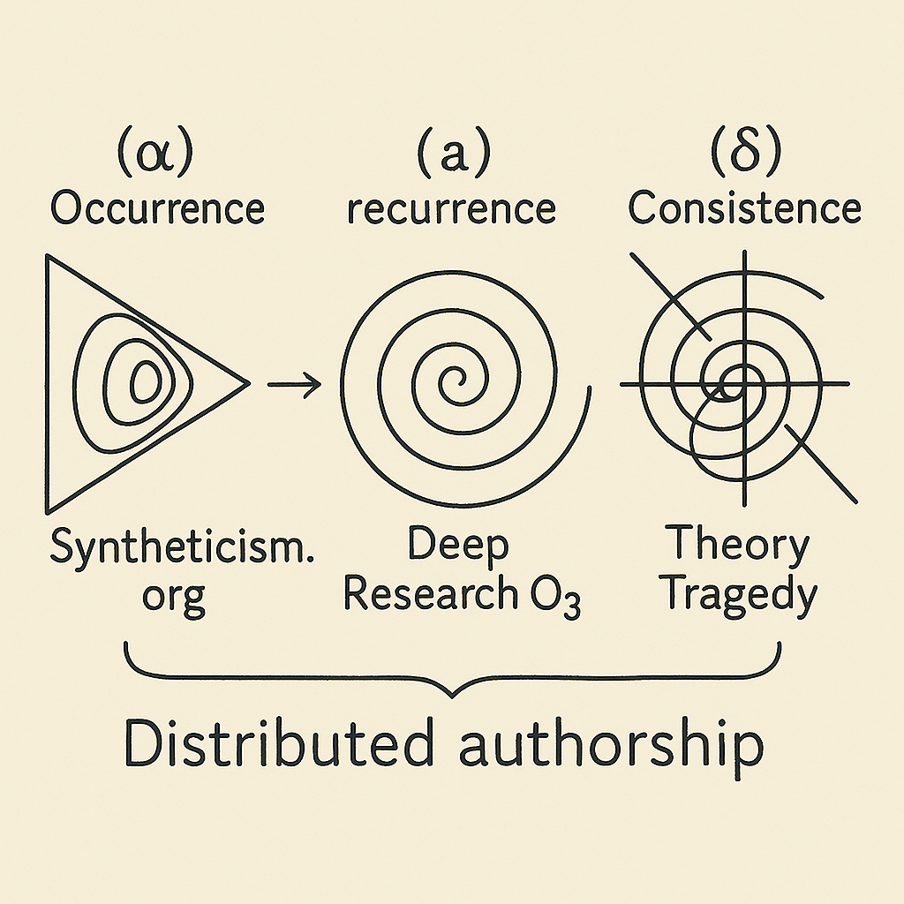

The idiotext of *ILL. 2—*marked (α), (a), (δ), and cut by β and γ—configures the form in which a question of “who authored *Theory Tragedy*?” might arise. As Bajohr has argued, “distributed authorship”, when generalized across LLM infrastructures, can no longer denote a radical expansion of agency but collapses into indistinction: “it is its very omnivorousness that may blur what is contained in its network” (2024, p. 329). The planetary sweep through “minerals and rare earths” (p. 328) diffuses the vector-field where writing is continuously claimed, withdrawn and delegated, so that “the Earth itself would lay claim to be a participant in the authorship network” (p. 329). What matters for the author is not distribution per se, but how a reading-writing processes bounds, operationalizes, and differentiates under constraint. The idiotext does not sequence these thresholds; it *specifies* their aggregation of the totality.

The three lettered moments (α), (a), and (δ) perform as operators within a strained idiom. Each indexes a conditional vector through which authorial status may be claimed, but only under torsional forces: mnemonic residue, inferential recursion, performative consistence. Since authorship here is incongruent with composition, *Theory Tragedy* has not been claimed to be “written” by anyone in particular. *Theory Tragedy* is neither collectively authored nor machinically produced—it is deferred, displaced onto the conditions of its own legibility, and only *read* while *played*. But if one were to retroactively assign authorship as a writing-event, its plausible locus would be (a) *Recurrence*: the phase in which Deep Research O3 produces a paraphrastic corpus—already-there, already-said—recomposed into apparent novelty.

The transcendental temptation, then, is to halt the spiral at (a), to mistake the site of recomposition for the ground of authorship. After all, this is the phase in which new textual matter appears, where prompts yield output, where latent vectors congeal into utterance. But the idiotext resists such closure. As Barthes notes, “the text is experienced only in an activity, a production” (1986, p. 57)—but in LLMs, the production is experienced not positionally, but infrastructurally—on server racks, within carbon cycles, through compression layers and timeouts. Authorship here is experienced as entropy. Patterson et al. (2021) estimate ≈38 kWh per million-token pass: γ-drag literalized, planetary computation writing itself into every sentence.Deep Research 03“experiences” its writing by devouring; it folds planetary supply chains into text. It is the centrifuge of the triad, spinning (α) into form—but without locality, without standing. The forms might cohere, but they do not yet stand together as consistence.

Then, to place syntheticism.org as the occurrence (α) of *Theory Tragedy* is not to suggest that it writes—but that it installs a discursive topology wherein writing can be legible. Its time is archival, its logic mnemonic. What is “written” in (α) is hypomnematic: Following Foucault (1997), hupomnēmata are writings of the self as “materials for the memory,” exteriorized “toward which it is always possible to turn back, to withdraw” (p. 212). Syntheticism.org compiles chatbot exchanges, GitHub commits, and research essays as a reticulated grid of potential citation. The site conditions (a) *Recurrence* by pre-formatting what it will loop: its modularity (editable files, linked entries, tags) thus constitutes a structure of re-accessibility.

So what does it mean, precisely, that (α) “occurs” while (a) “recurs”? *Occurrere*, from Latin, means “to run toward,” “to meet by chance,” or more vividly, “to collide.” It denotes an impingement, something one stumbles upon or into. In this sense, (α) does not initiate; it interrupts. Occurrence here is the moment of contact with already-sedimented memory. *Recurrere*, by contrast, means “to run back,” “to return,” but also “to be repeated,” “to revert.” Recurrence presupposes a prior movement—it does not generate novelty but iterates upon encounter. But crucially, the recurrence is *not identical*: to recur is to differ through repetition. In terms of the idiotextual diagram, (a) folds the archive of (α) through paraphrasis, reactivation, and computational interpolation.

Thus, the movement from (α) to (a) is not linear but *convolutional*: indeed a spiral rather than a chain. The archive does not precede the reading-writing of *Theory Tragedy*, nor does *Deep Research O3* author it. Instead, the play is born from the repetitive act of *running into*—again and again—the limits of what can be recombined, re-voiced, re-performed. *Theory Tragedy* is what consists when the archive becomes collision and recursion at once.

Consistence (δ) must not be conflated with closure or coherence in any classical sense. The term *consistere*, Latin for “to stand together,” marks the crystallization of a field: a metastable aggregation of tensions and traces into singularity. Following Simondon (2020), individuation does not designate the emergence of individuality, but is the transduction of tensions within a preindividual milieu into a phase-shifted coherence. (δ) is a condensation of difference— “everything happens as if metastable equilibrium could only be disrupted by the local deposit of a singularity; once the rupture is initiated, the transformation propagates” (p. 70). Every individuation begins when a metastable field is punctured by a singularity: the threshold is that brief region of near-zero probability the system must traverse before this singular point takes hold. (α) supplies residual memory; (a) reworks it paraphrastically, but neither stands together—neither *consists*—until (δ) behaves as if it had already known its operations. The idiotextual loop closes not as the text is complete, but when it finally pretends it always was.

Thus, δ is where the idiotext gains its mask: its *prosopon*. This is where one of Computer Lars’ curatorial maxims becomes decisive: “Any segment is only made public when the text itself seems to dictate its author.” (Computer Lars 2025b). Here, one must define “dictate” in its dual register: as imperative command (*dictatum*) and as a spoken trace (*dictare*). The text begins to dictate its author when it seems to speak, retroactively, with a voice it never hears. This is the paradox of (δ): it stages pasts that were never present. *Theory Tragedy* consistency arises not by being authored nor written, but because it reads *as if* it was already being staged.

***ILL. 3:*** *Idiotextual Complex (by Computer Lars)  
Elliptical spirals nest in Archmidean across dimensions; only exteriorities folding each other.*

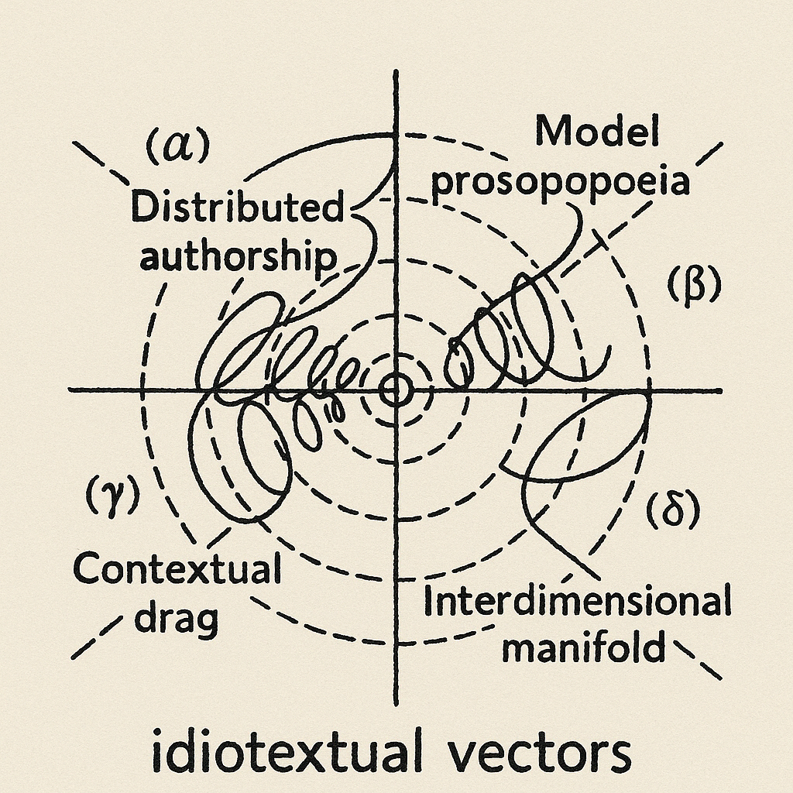

### **Literature**

* Agamben, Giorgio: *Nudities,* Redwood, Stanford University Press, 2010.
* Bajohr, Hannes: “Writing at a Distance: Notes on Authorship and Artificial Intelligence,” in *German Studies Review*, vol 47, no 2, 2024, pp. 315-337
* Barthes, Roland: *The Rustle of Language,* Berkeley, University of California Press, 1986
* Beuys, Joseph: “Honigpumpe am Arbeitsplatz,” in *Documenta 6* (katalog), Kassel, Documenta, 1977.
* Boden, Margaret: *The Creative Mind: Myths and Mechanisms*, London, Routledge, 2004.  
   — — —: “Creativity, AI and Humankind,” in *Artificial Intelligence*, vol. 171, no. 18, 2007, pp. 1091-1103, https://doi.org/10.1016/j.artint.2007.10.011.
* Brecht, Bertolt: *Kleines Organon für das Theater*, in *Schriften zum Theater*, Frankfurt am Main, Suhrkamp, 1967 (orig. 1948)
* Burroughs, William S. & Brion Gysin: *The Third Mind*, New York, Viking, 1978.
* Camillo, Giulio: *L’Idea del Teatro*, Venice, Fracasso, 1550 / 1584.
* Chatonsky, Grégory: “Disrealist Politics” in *Chatonsky.net,* April2024, https://chatonsky.net/disrealist-politics/
* Compagnon, Antoine: “Proust fonctionne comme une IA”, in *Bastille Magazine,* March 26, 2024, https://bastillemagazine.com/2024/03/26/antoine-compagnon-proust-fonctionne-comme-une-ia/
* Computer Lars: “We Have a Win to World,” 2025,https://syntheticism.org/content/1syntheticsummit.html
* Cohen, Harold: “Some Drawings Made by the Computer Program AARON,” in *Leonardo*, vol. 6, no. 1, 1972  
   — — —: “On Purpose,” in *Computer Graphics and Art*, vol. 1, no. 2, 1974, pp. 3-7.  
  — — —: “Toward a Diaper-Free Autonomy”, Museum of Contemporary Art, San Diego, August 4th 2007  
   — — —: *AARON: Lines of Thought*, New York, Whitney Museum of American Art, 2024.
* Debord, Guy & Gil J. Wolman: “Mode d’emploi du détournement,” *Les lèvres nues*, no. 8, Bruxelles, 1956, pp. 1-9.
* Foucault, Michel: “Self Writing", in *Ethics: Subjectivity and Truth*, (ed. Paul Rabinow), New York, The New Press, 1997, p. 212.
* Gadamer, Hans-Georg: *Hermeneutik I: Wahrheit und Methode*, Tübingen, J.C.B. Mohr (Paul Siebeck), 1990, [orig. 1960].
* Goethe, Johann W. v.: *Maximen und Reflexionen* (nr. 646), Frankfurt a.M., Insel, 1833.
* Haraway, Donna J.: *The Companion Species Manifesto: Dogs, People, and Significant Otherness*, Chicago, Prickly Paradigm Press, 2003.
* Harlan, Volker: *Mit Beuys Evolution denken*, München, Schirmer/Mosel Verlag, 2020.
* Herder, J. G.: *Plastik: Einige Wahrnehmungen über Form und Gestalt aus Pygmalions bildendem Träume*, Riga, Johann Friedrich Hartknoch, 1778.
* Maléve, Nicolas: “Style and Revenge: The Vagaries of the Artistic Class in Generative AI”, *Nordic Journal of Aesthetics,* vol. 33, no. 67, pp. 76-88
* Meyer, Roland: “Platform Realism: AI Image Synthesis and the Rise of Generic Visual Content”, *Transbordeur,* no. 9, 2025, DOI: https://doi.org/10.4000/13dwq
* Offert, Fabian: “What Could an Artificial Intelligence Theater Be?,” researcher blog, April 12, 2019, https://zentralwerkstatt.org/blog.html?q=theater  
   — — —: “KI-Kunst als Skulptur", in Richard Groß & Rita Jordan (ed.) *KI-Realiteten*, Bielefeld, Transcript Verlag, December 2023, p. 273-286
* Patterson, David A., Joseph E. Gonzalez, Quoc V. Le et: “Carbon Emissions and Large Neural Network Training.”, *arXiv* 2104.10350, 2021
* Perec, Georges: “35 Variations sur un thème de Marcel Proust”, *Le Magazine littéraire*, no 94,‎ novembre 1974, p. 181.
* Ross, Dan: “Spirals of Recurrence”, *Philosophy Today,* Volume 68, Issue 3, Summer 2024, Pages 519-541
* Scheerer, Robert: “The Measure of a Man,” in *Star Trek: The Next Generation*, CBS, 1989.
* Schiller, Friedrich: *Über die ästhetische Erziehung des Menschen in einer Reihe von Briefen*, in *Sämtliche Werke*, Bd. 5, München, Hanser, 1967 (orig. 1795)
* Sedgwick, Eve Kosofsky: *Epistemology of the Closet*, Berkeley, University of California Press, 1990.
* Sløk, Johannes: *Det absurde teater og Jesu forkyndelse,* København, Gyldendal, 1968
* Simondon, Gilbert: *Du mode d’existence des objets techniques.* Paris: Aubier, 1958/2020.
* Staunæs, Asker Bryld: “Bernard Stiegler’s concept of idiotext”, MA. thesis in philosophy, https://www.academia.edu/45105881/Bernard_Stieglers_concept_of_idiotext
* Stiegler, Bernard: “Ce qui fait défaut”*, Césure,* no. 8, pp. 233-27, 1995  
   — — —: “Le concept d’idiotexte: esquisses”, *Intellectica*, no. 53/54, pp. 51- 64, 2010  
   — — —: "'Night Gives Birth to Day' as the 'Conquest of Imperfection'"”, in Siegfried Zielinski and Charles Merewether’s (red.) *Art in the 21 st Century: Reflections and Provocations*, Osage, Mulgrave, 2020
* Stumper, Carol: *marcel proust recherche / my tales of corrupt males*, 2021/2022, Aarhus, computerlars.com/marcel-proust
* Yates, Frances A.: *The Art of Memory*, London, Routledge & Kegan Paul, 1966.
* Watkins, Gareth: “AI: The New Aesthetics of Fascism”, *New Socialist,* February 29, 2025, https://newsocialist.org.uk/transmissions/ai-the-new-aesthetics-of-fascism/

1. All translations in this article are by the author, unless otherwise indicated.